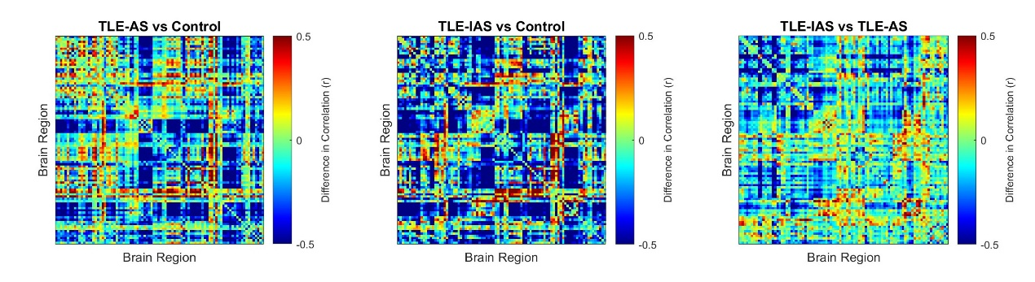
Supplementary Fig. 1. Metabolic connectivity difference matrices for pairwise comparisons among the control, TLE-AS, and TLE-IAS groups. Abbreviations: TLE-AS, temporal lobe epilepsy-aware seizures; TLE-IAS, temporal lobe epilepsy-impaired awareness seizures.

